**Lime Mint Tea**

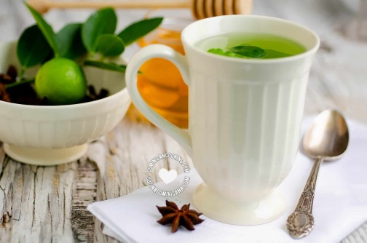

**INGREDIENTS**

12 leaves from a lime or lemon tree, rinsed

6 mint leaves

1 lime or lemon slices

4 tablespoons Honey , or sugar, or to taste

**METHOD**

1. Boiling: In a deep saucepan (preferably stainless steel) heat 8 cups [2 liters] of water until it comes to a boil.
2. Add the lime and mint leaves and cook over very low heat until the water has reduced to half or has a light green color.
3. Remove from the heat and add 1 tablespoon of lime juice. Remove leaves.
4. Serving: Sweeten with honey or sugar to taste.
5. Serve hot.